**Hello World RESTful Web Service**

**SpringLearnApplication.java:**

package com.cognizant.spring_learn;

import org.springframework.boot.SpringApplication;

import org.springframework.boot.autoconfigure.SpringBootApplication;

@SpringBootApplication

public class SpringLearnApplication {

public static void main(String[] args) {

SpringApplication.*run*(SpringLearnApplication.class, args);

}

}

**HelloController.java**

package com.cognizant.spring_learn.controller;

import org.slf4j.Logger;

import org.slf4j.LoggerFactory;

import org.springframework.web.bind.annotation.GetMapping;

import org.springframework.web.bind.annotation.RestController;

@RestController

public class HelloController {

private static final Logger *LOGGER* = LoggerFactory.*getLogger*(HelloController.class);

@GetMapping("/hello")

public String sayHello() {

*LOGGER*.info("START");

String message = "Hello World!!";

*LOGGER*.info("END");

return message;

}

}

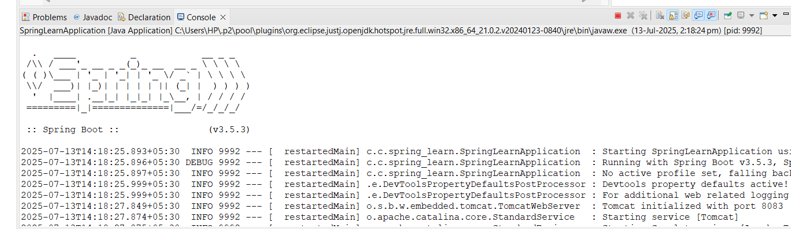

**OUTPUT:**

